import java.util.Scanner;
public class One {
public static void main(String[] args) {
try (Scanner scan = new Scanner(System.in)) {
System.out.print("Enter a number: ");
double number = scan.nextDouble();
if (number % 1 != 0) {
System.out.println("The number is not an integer, so it cannot be even or odd.");
} else {
int num = (int) number;
if (num % 2 == 0) {
System.out.println(num + " is even.");
} else {
System.out.println(num + " is odd.");
}
}
}
}
}

Code:
Write a Java program to check whether the given number is odd or even

Question 1:
Week 4

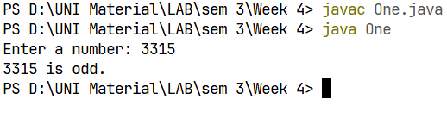
Output:

Code:
Write a Java program to find the largest number among the three numbers.

Question 2: 1
import java.util.Scanner;
public class Two {
public static void main(String[] args) {
try (Scanner scan = new Scanner(System.in)) {
System.out.print("Enter first number: ");
double num1 = scan.nextDouble();
System.out.print("Enter second number: ");
double num2 = scan.nextDouble();
System.out.print("Enter third number: ");
double num3 = scan.nextDouble();
double largest;

if (num1 >= num2 && num1 >= num3) {
largest = num1;
} else if (num2 >= num1 && num2 >= num3) {
largest = num2;
} else {
largest = num3;
}
System.out.println("The largest number is: " + largest);
}
}
}

Code:

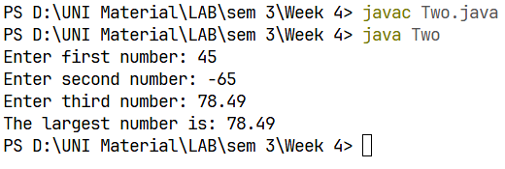
Output:

Code:
Write a Java program that takes a number as input and prints its multiplication table up to 10

Question 3:
import java.util.Scanner;
public class Three {
public static void main(String[] args) {
try (Scanner scan = new Scanner(System.in)) {
System.out.print("Enter a number: ");
int number = scan.nextInt();
System.out.println("Multiplication Table of " + number + ":");
for (int i = 1; i <= 10; i++) {
System.out.println(number + " x " + i + " = " + (number * i));
}
}
}
}

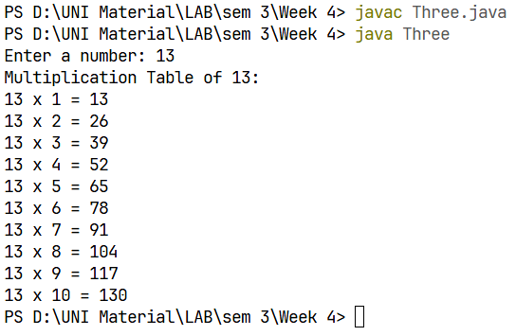

Output:

import java.util.Scanner;
public class Four {
public static void main(String[] args) {
try (Scanner scan = new Scanner(System.in)) {
System.out.print("Enter the value of N: ");
int N = scan.nextInt();
int sum = 0;
for (int i = 1; i <= N; i++) {
sum += i;
}
System.out.println("The sum of the series 1 + 2 + ... + " + N + " is: " + sum);
}
}
}

Code:
Write a Java program to calculate the sum of following series:
1 + 2 + 3 + 4 + .......... + N

Question 4:

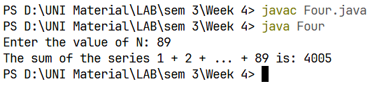
import java.util.Scanner;
public class Five {
public static void main(String[] args) {
try (Scanner scan = new Scanner(System.in)) {
System.out.print("Enter a number: ");
int number = scan.nextInt();
if(number < 10)
System.out.println("Number is less than 10, please enter more than 10");
while (number >= 10) {
System.out.print(number + " / 2 = " + (number/2) );
number = number / 2;
}
}
}
}

Code:
Write a Java program to take a number, divide it by 2 and print the result until the number becomes less than 10

Question 5:
Output:
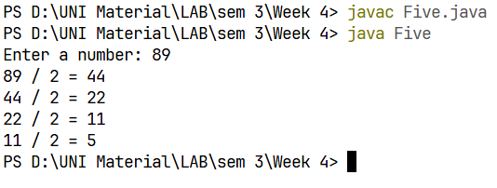
Output:
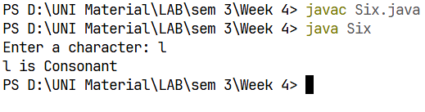
Output:
Question 6:
Write a Java program to check whether a given character is a vowel or consonant.

Code:
import java.util.Scanner;
public class Six {
public static void main(String[] args) {
try (Scanner scan = new Scanner(System.in)) {
System.out.print("Enter a character: ");
char ch = scan.next().charAt(0); // get the first character of input
ch = Character.toLowerCase(ch);
if (!Character.isLetter(ch)) {
System.out.println("Invalid input. Please enter an alphabet character.");
} else if (ch == 'a' || ch == 'e' || ch == 'i' || ch == 'o' || ch == 'u') {
System.out.println(ch + " is Vowel");
} else {
System.out.println(ch + " is Consonant");
}
}
}
}

Optional
import java.util.Scanner;
public class Seven {
public static void main(String[] args) {
try (Scanner scan = new Scanner(System.in)) {
System.out.print("Enter first number: ");
double num1 = scan.nextDouble();
System.out.print("Enter second number: ");
double num2 = scan.nextDouble();
System.out.print("Enter third number: ");
double num3 = scan.nextDouble();
System.out.print("Enter fourth number: ");
double num4 = scan.nextDouble();
double smallest = Math.min(Math.min(num1, num2), Math.min(num3, num4));
System.out.printf("The smallest number is: %.2f", smallest);
}
}
}

Question 7:
Code:
Write a Java program to find the smallest number among four given numbers.

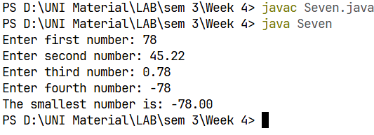
Output:
import java.util.Scanner;
public class Eight {
public static void main(String[] args) {
try (Scanner scan = new Scanner(System.in)) {
System.out.print("Enter the value of N: ");
int N = scan.nextInt();
int sum = 0;
for (int i = 2; i <= N; i += 2) {
sum += i;
}
System.out.println("Sum of all even numbers from 1 to " + N + " is: " + sum);
}
}
}

Code:
Write a Java program to calculate the sum of all even numbers from 1 up to a given number N.

Question 8:
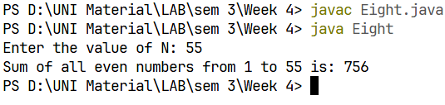
Output:
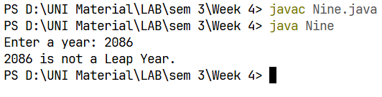
import java.util.Scanner;
public class Nine {
public static void main(String[] args) {
try (Scanner scan = new Scanner(System.in)) {
System.out.print("Enter a year: ");
int year = scan.nextInt();
if ((year % 4 == 0 && year % 100 != 0) || (year % 400 == 0)) {
System.out.println(year + " is a Leap Year.");
} else {
System.out.println(year + " is not a Leap Year.");
}
}
}
}

Question 9:
Code:
Write a Java program to check whether a given year is a leap year or not

Output:
Question 10:
Write a Java program that takes a number as input and prints all its factors

Output:
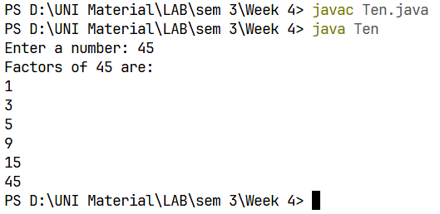
Output:
Code:
import java.util.Scanner;
public class Ten {
public static void main(String[] args) {
try (Scanner scan = new Scanner(System.in)) {
System.out.print("Enter a number: ");
int number = scan.nextInt();
System.out.println("Factors of " + number + " are:");
for (int i = 1; i <= number; i++) {
if (number % i == 0) {
System.out.println(i);
}
}
}
}
}

